Alert Watch and Response Engine (AWARE)

Knowledge Based Editor and Alert Cache Installation Guide



January 2014

Prepared by Harris Corporation

Revision History

| Creation Date | Version No. | Description/Comments | Author(s) | Reviewer(s) | Review Type | Issue Date |
| --- | --- | --- | --- | --- | --- | --- |
| 1/29/2014 | 0.01 |  | B. Tjahjo |  |  |  |
|  |  |  |  |  |  |  |
|  |  |  |  |  |  |  |
|  |  |  |  |  |  |  |
|  |  |  |  |  |  |  |

Table of Contents

1 Introduction 1

1.1 Pre-installation considerations 1

1.2 Preparation 1

2 Installation 1

2.1 Cache Server: Create CSP AWARE Web Application 1

2.2 Cache Server: Import Source Code XML 5

2.3 Cache Server: Edit Cache User CSPSystem 7

2.4 IIS WEB Server: Assign IIS_IUSRS full control to c:\inetpub 10

2.5 IIS Web Server: Install CSP Gateway 12

2.6 IIS Web Server: Configure CSP Web Server 16

2.7 IIS Web Server: Copy the AWARE folder 18

2.8 Test the URL 18

# Introduction

This document provides installation guide for Knowledge-Based (KB) Editor and Alert Cache. Both KB Editor and Alert Cache are web-based applications designed to be used together with VistA AWARE. Please refer to Technical documents and User Guides for more information regarding KB Editor and Alert Cache.

All sections of this guide can be performed by an IRM programmer and may require coordination with facility or regional server manager.

## Pre-installation Considerations

This document presents instructions for installing KB Editor and Alert Cache with examples using test account. **Note:** The screen captures in this guide depict steps taken using Intersystems Cache 2011 and Web Server IIS 7.5 on Windows Server 2003.

Since KB Editor and Alert Cache server side codes are written in Cache Server Page (CSP), the majority of this document will focus on CSP related installation.

Install and test this software in test accounts prior to installation in production accounts.

## Preparation

1. A fully operational Web Server (IIS 6 /7.x or Apache 2.0.x)
2. Cache Server Page (CSP) Gateway installer. The CSP Gateway installer should have the same version of the VistA Cache Server. CSP Gateway can be obtained from Intersystems WRC site. Full Cache installer can also be used to install CSP gateway by selecting only the Web Server Gateway option.
3. Fully-patched AWARE package must be installed to test the web applications.
4. AWARE CSP Installation file for Cache Server (VEFA_1_0_x_SERVER.CSP). Save this file on a temporary folder of the Cache Server or a workstation that has Cache Client installed.
5. AWARE CSP Installation file for Web Server (VEFA_1_0_x_IIS.ZIP). Save this file on a temporary folder in the Web Server.

# Installation

## 2.1 Cache Server: Create CSP AWARE Web Application

Use the System Management Portal to create a CSP Application.

1. Right click **Cache Cube** and select **System Management Portal**.

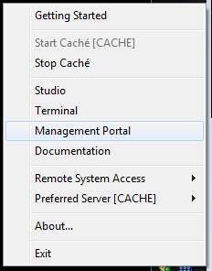

1. Access **Web Application** by traversing **System Administration, Security, Applications, Web Applications**, and click on **GO** button to add Web application.

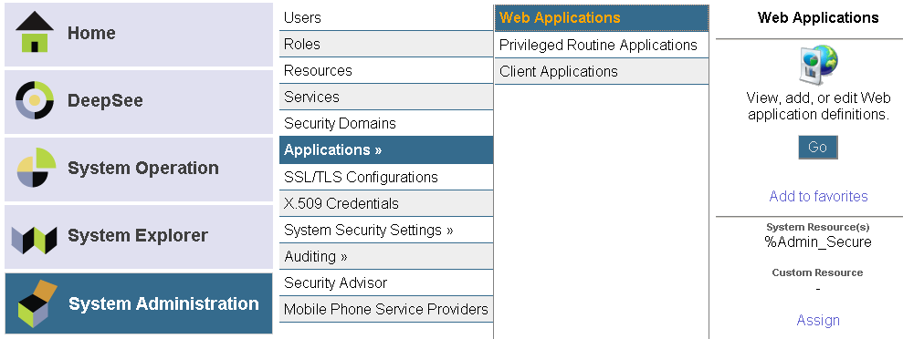

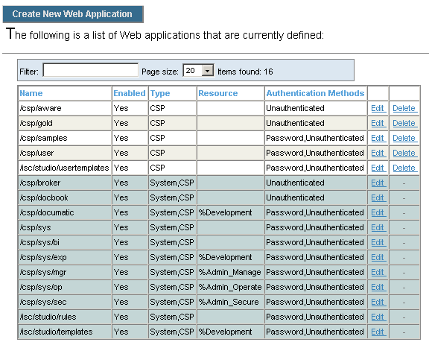

1. Click **Create New Web Application** button

The example below is from the sandbox I2008 VistA Amazon cloud-2 environment.

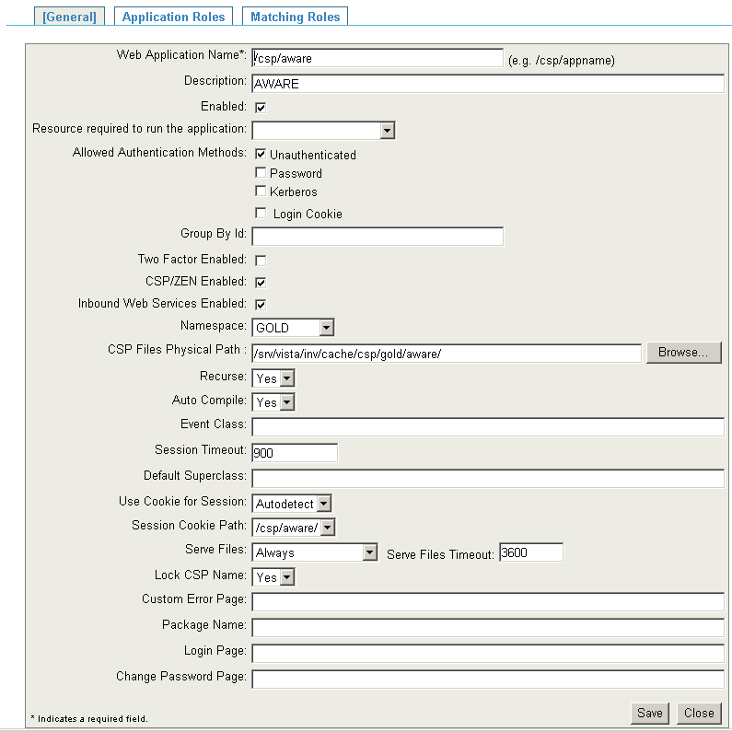

Change the Namespace and CSP Files Physical Path to reflect appropriate namespace and path.

The structure of the path depends on the OS where Cache Server is installed.

For Windows: <drive>:\<cache-install-dir>\CSP\<namespace>\aware\

For UNIX: /<Cache Install-dir>/csp/<namespace>/aware/

For VMS: adjust appropriately. Example: XXX_CACHE$:[XXX.CSP.AWARE] where XXX indicates the 3 characters site identifier

1. Click **Save**.
2. Click on the Application Roles tab and select %DB_%DEFAULT then click **Assign** button.

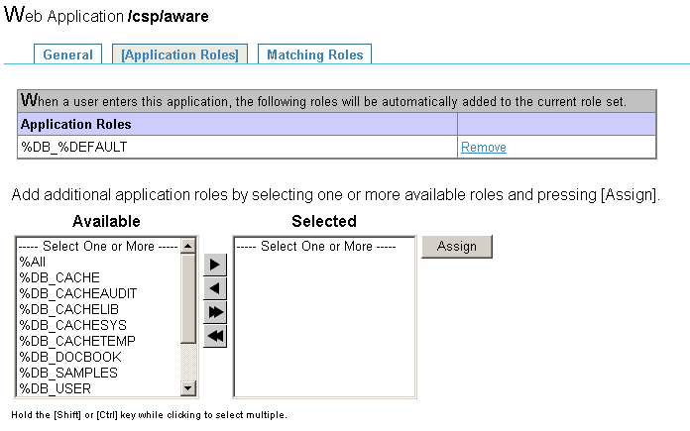

1. The CSP application is now configured for AWARE Web Application.
2. Log off the System Management Portal.

## 2.2 Cache Server: Import Source Code XML

Use Cache Studio to import source code XML.

1. Right click **Cache Cube** and select **Studio**.



1. Click the **Tool** menu and select **Import Local**.
2. Browse to XML source code file included with the installation files.

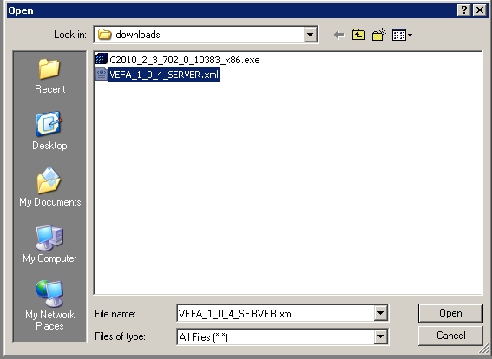

1. Click the **Open** button.

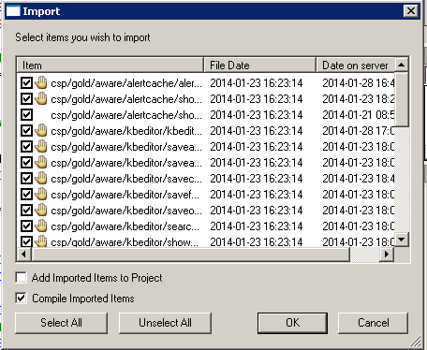

1. Ensure the **Add Imported Items to Project** checkbox is not selected.
2. Click the **OK** button to import **AWARE KB Editor and Alert Cache .csp and .cls** files.

## 2.3 Cache Server: Edit Cache User CSPSystem

1. Access **Users** by traversing **System Administration, Security, Users.**

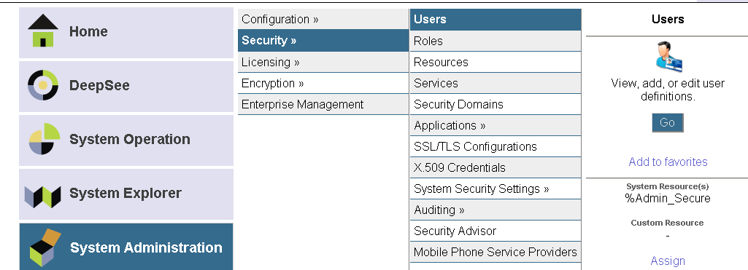

1. Click on **GO** button.

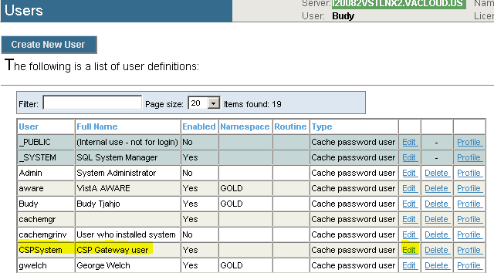

1. Click on Edit link for user CSPSystem.

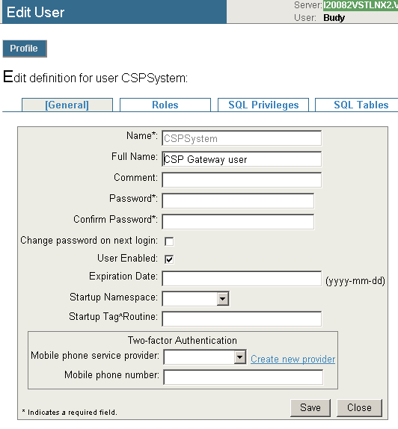

Modify and confirm CSPSystem password. This password will be entered in the CSPGateway Management later in this document.

1. Assign %DB_DEFAULT role to user CSPSystem.

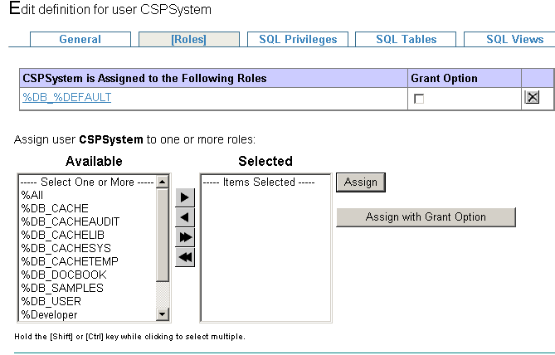

## 2.4 IIS Web Server: Assign IIS_IUSRS full control to c:\inetpub

1. On IIS Web Server’s Window Explorer, go to C:\ drive.
2. Right Click on inetpub and select properties.

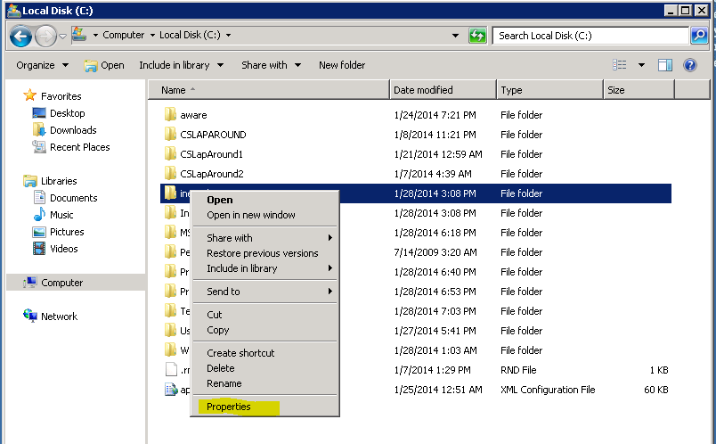

1. On Security tab, click Edit button.

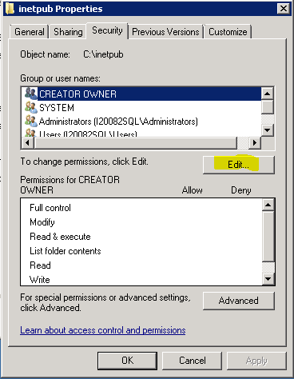

1. On Permissions for inetpub windows, Security tab, click Add button.

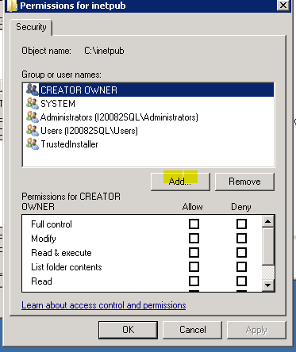

1. On the Enter the object names to select edit box, enter <COMPUTER>\IIS_IUSRS and click Check Names

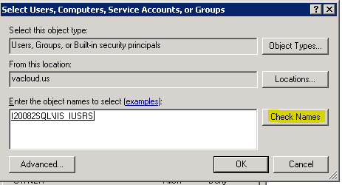

1. Assign Full control to IIS_IUSRS by clicking the allow Full Control check box.

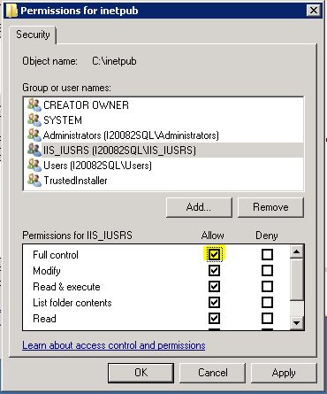

1. Hit OK to save.

## 2.5 IIS Web Server: Install CSP Gateway

Intersystems CSP Gateway Configuration Guide inside Cache documentation offers detail information on how to install CSP Gateway on various environments.

Steps below shows how CSP Gateway is installed on the following Sandbox test environments:

1. Windows Server 2008 64-bit Operating System.
2. IIS 7.5 is used as the Web Server.
3. Cache Server: Cache 2011.1.2

Based on that configuration CSP Gateway installer (Cache.2011.1.6.CSPGateway_x64.exe) was downloaded from Intersystems WRC site. Cache 2011.1.2 version of CSP Gateway to match Cache Server version is unavailable.

The installer must have administrator right. If the installer’s login account is not administrator, the installer must run the installer with “run as administrator” option.

1. Run the CSPGateway installer and hit Next button couple times until **Server Connection Information** is shown.

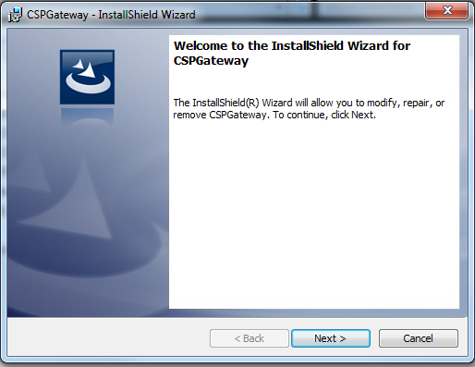

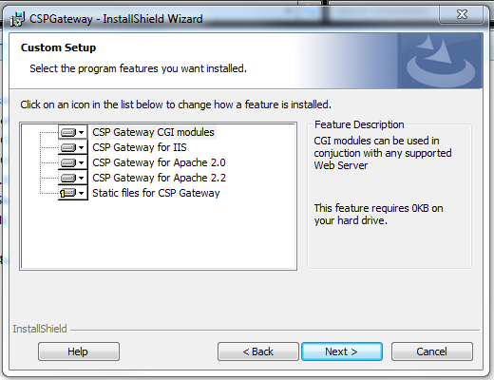

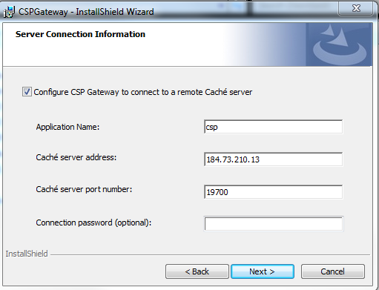

1. **Application Name**: csp
2. **Cache Server address**: <enter Cache Server IP Address>.
3. **Cache server port number**: <enter Cache TCP Port>. This is Cache superserver port number which has default of 1972. Change the port number to reflect the real superserver port number set in the Cache’s System memory and Startup Settings. This is **\*\*not\*\*** the Web Server Port.
4. Click **Next** thenclick **Install** on the next form.

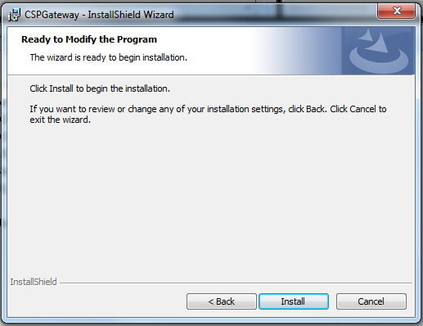

Upon successful completion of the install, the IIS should have the following modifications and should be verified.

1. Verify Application csp was added by
2. Run IIS with run as administrator option.
3. Expand the COMPUTER\USER view.
4. Expand Sites view.
5. Expand Default Web Site view.
6. Verify Application csp was added.

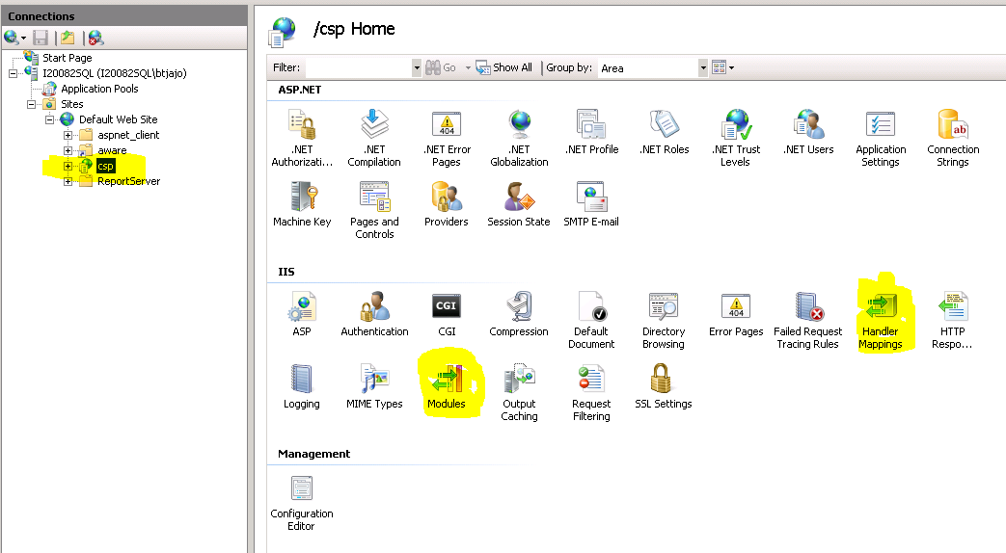

1. Verify CSPms Module was added by
2. Still on the Default Web Site view, click on application csp.
3. Double click on Modules icon in the middle section.
4. Verify CSPms was added.

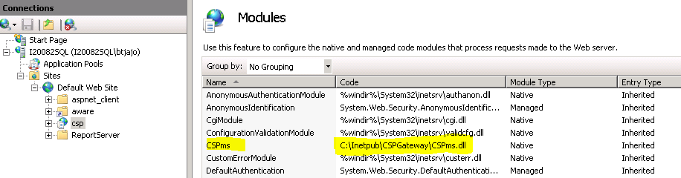

1. Verify CSPGateway_*.csp, *.cls, *.cxw, *.zen module mappings were added by
2. Back to the Default Web Site view and click on application csp.
3. Double click on Handler Mappings icon.
4. Verify those CSPGateway_*.csp, *.cls, *.cxw, *.zen mappings were added.

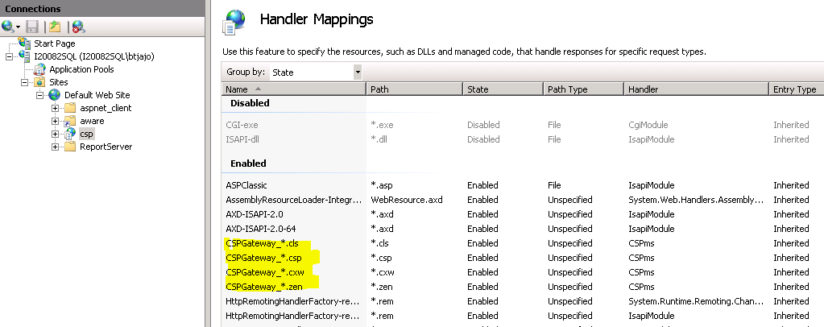

## 2.6 IIS Web Server: Configure CSP Web Server.

1. Access CSP Gateway via a web browser

(<http://localhost/csp/bin/Systems/Module.cxw>)

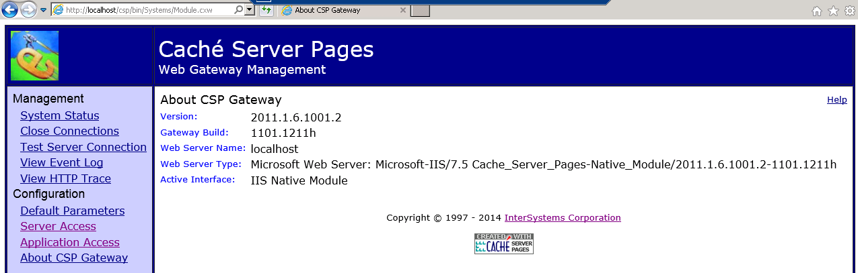

1. Click on Server Access and select csp and hit Submit

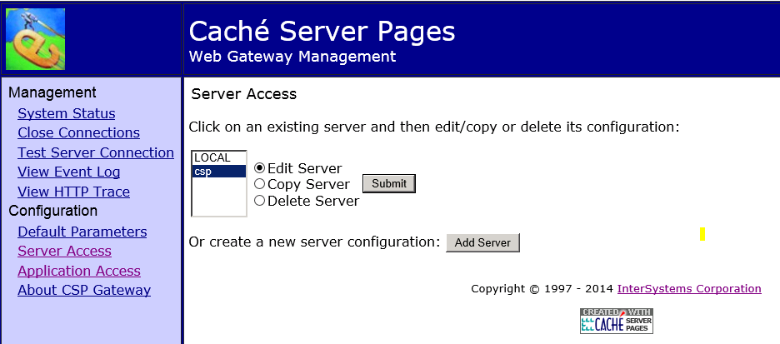

1. Verify IP Address and TCP Port

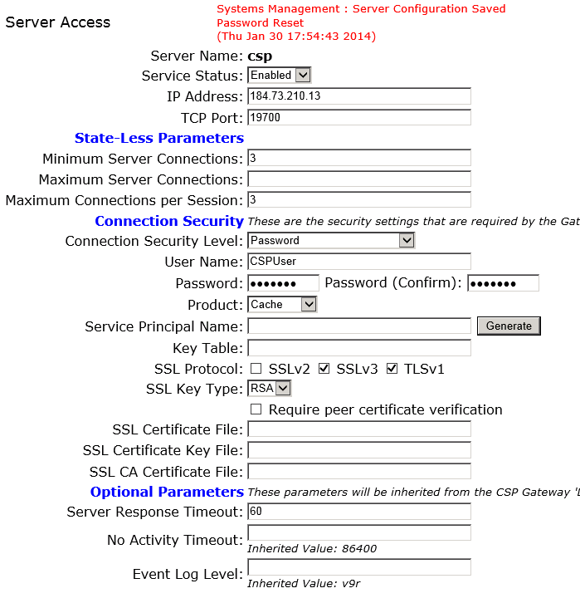

1. Enter user Name: CSPSystem
2. Enter Password: <CSPSystem password>
3. Password (confirm): <CSPSystem password>
4. Click on Save Configuration button at the bottom of the page.
5. On the Cache Server Pages, click on Application Access and confirm application /csp exists

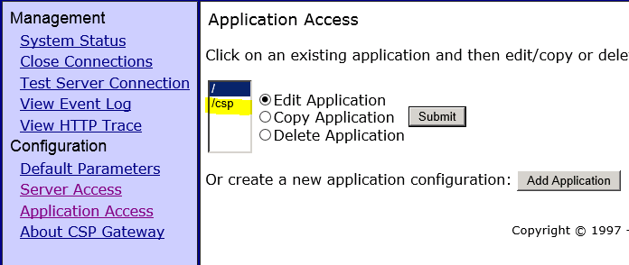

## 2.7 IIS Web Server: IIS Web Server: Copy the AWARE folder

Copy and paste the AWARE folder included in the VEFA_1_0_x_IIS.zip file into the CSP folder of the CSP Gateway installation directory, e.g, c:\intersystems\CSPGateway\csp

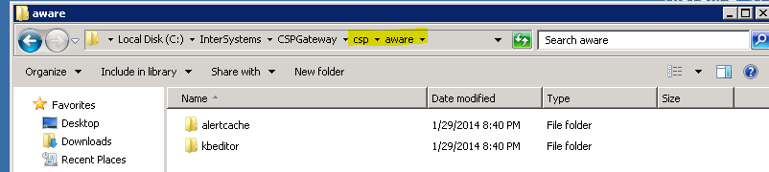

## 2.8 Test the URL

Test the URL via a web browser.

http://<HOST>/csp/aware/kbeditor/kbeditor.csp

http://<HOST>/csp/aware/alertcache/alertcache.csp